
PROJECT TITLE:
ONLINE SMS SITE



INSTRUCTOR : SIR KAMRAN HYDER

Table of Contents

ACKNOWLEDGEMENT 3
PROJECT DESCRIPTION 4
TASK SHEETS 5
PROJECT SCREEN SHOT 7
CODES SCREENSHOTS 12
DATABASE SCREENSHOTS 14
ERD DIAGRAM 14
FLOWCHART DIAGRAM 15

ACKNOWLEDGEMENT

We would like to express our deepest gratitude to Sir Kamran for his continuous guidance, support, and encouragement throughout this project. His valuable suggestions and expert knowledge helped us in understanding and completing the Online SMS Site successfully.
This project has enhanced our learning experience and improved our technical and analytical skills.
We are also thankful to our classmates for their cooperation and constructive feedback during the development process.
Special thanks to our group members for their teamwork and collaboration. Working on this project gave us an opportunity to apply our theoretical knowledge in a practical environment.
It also helped us understand the importance of systematic planning and coordination.
We are truly grateful to everyone who directly or indirectly contributed to the completion of this project.
Lastly, we sincerely appreciate the learning environment provided by our teacher that made this achievement possible.

PROJECT DESCRIPTION

The Project is to be developed where the user is allowed to register their mobile number on the site and they will be allowed to send the message to any mobile. There is certain validation for the user to send the message like it should not exceed more than 120 characters. Only 5 messages are allowed to send free to any single mobile number. Once the message is send then the appropriated message must be prompted. Even user can also edit the profile by adding personal, professional details. Once the profile is created the user can be allowed to add the other registered users by sending the request. Once the request is accepted then his/her mobile number will be added in the friend list of the profile and sending message to the friend mobile number will be free unlimited through out the day. There will be contact page open for the user where they can enter the mobile number with the name of the person for sending the message. It also provide option for activating the service for the joke, current affairs, sports, news in your mobile, this would be paid service where user has to pay through credit card.

TASK SHEETS

Team Member | Student ID | Tasks
Muhammad Siddiq Azam | 1618102 | Information, Data Structure,  Flow Chart, Data Base, Backend
Dua Khan | 1617381 | Design Layout, Frontend, Login & Logout, Profile Update
Kinza Zeeshan | 1618090 | Friends & Request Page, Message Page, UI Design, Documentation









CERTIFICATE

OF COMPLETION

This certificate is proudly
presented to

2

0

2

6

Muhammad Siddiq Azam (Student 1618102)

Dua

Khan (Student 1617381)

Kinza Zeeshan (Student 1618090)

FOR SUCCESSFULLY
COMPLETED THE E
-
PROJECT
2026

PROJECT SCREEN SHOT

NAVIGATION BAR WITH HOME SECTION:

The Dashboard Section is the main area of the Online SMS Site, providing users with a centralized platform to access important features and updates. Its clean and organized design allows users to navigate the system easily and efficiently.

The Sidebar Navigation offers quick access to key sections such as Dashboard, Messages, Friends & Requests, Profile Setup, and Paid Services. This structured menu helps users move between different functionalities smoothly while maintaining a user-friendly experience.

The Global Dashboard Feed displays community posts, announcements, and updates shared by users. Features such as writing articles, viewing posts, and liking content encourage interaction and communication, making the platform more engaging and informative.

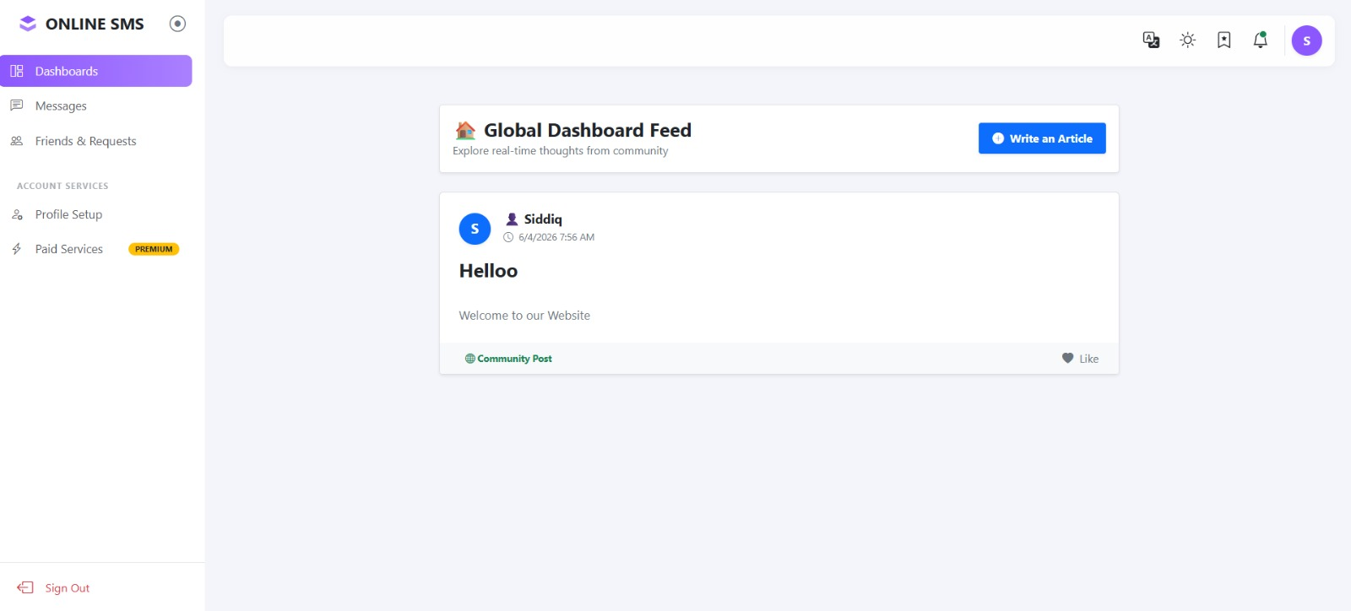

MESSAGES SECTION:

The Messages Section of the Online SMS Site enables users to communicate with others through a simple and organized chat interface. It provides real-time messaging functionality, making communication fast, convenient, and efficient.

The conversation panel on the left displays a list of contacts and active chats, allowing users to quickly select and access conversations. This structured layout helps users manage their messages without confusion.

The chat window on the right shows message history and provides a text box for sending new messages. Users can easily exchange information, stay connected, and maintain smooth communication within the platform.

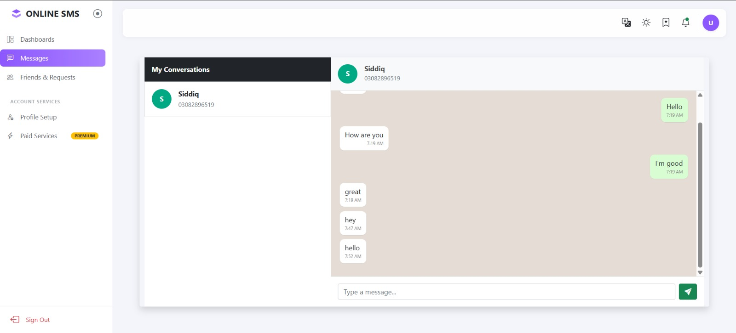

LOGIN & REGISTER PAGE:
The first screen shows a User Login page where users can enter their username or email along with their password to access their account. It has a simple and clean design with a “Sign In” button and a link for new users to create an account.
The second screen is a Create Account page that allows new users to register by entering their username, email, phone number, and password. It includes a “Sign Up” button for completing the registration process.
Both pages are connected, as users who don’t have an account can easily navigate to the signup page, while existing users can return to the login page. The design is user-friendly and focuses on smooth navigation between login and registration.

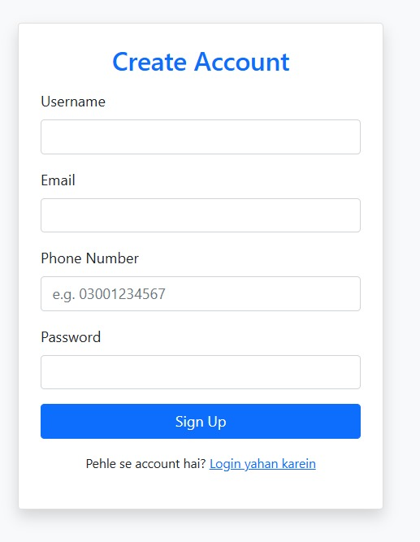
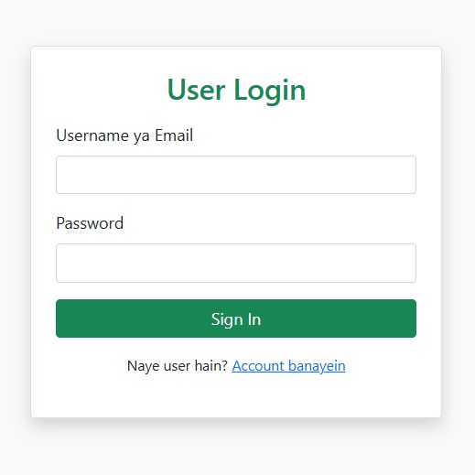

FRIEND & REQUEST:

The dashboard displays a Friends Network section where users can manage their connections. It includes a panel for pending friend requests, which currently shows no new requests.

On the right side, the Confirmed Friends Network lists added friends along with their contact details. Users can directly start a conversation using the “Chat Now” option.

Overall, the interface is clean and organized, allowing easy navigation between requests and confirmed friends while also providing a quick search feature to find contacts.

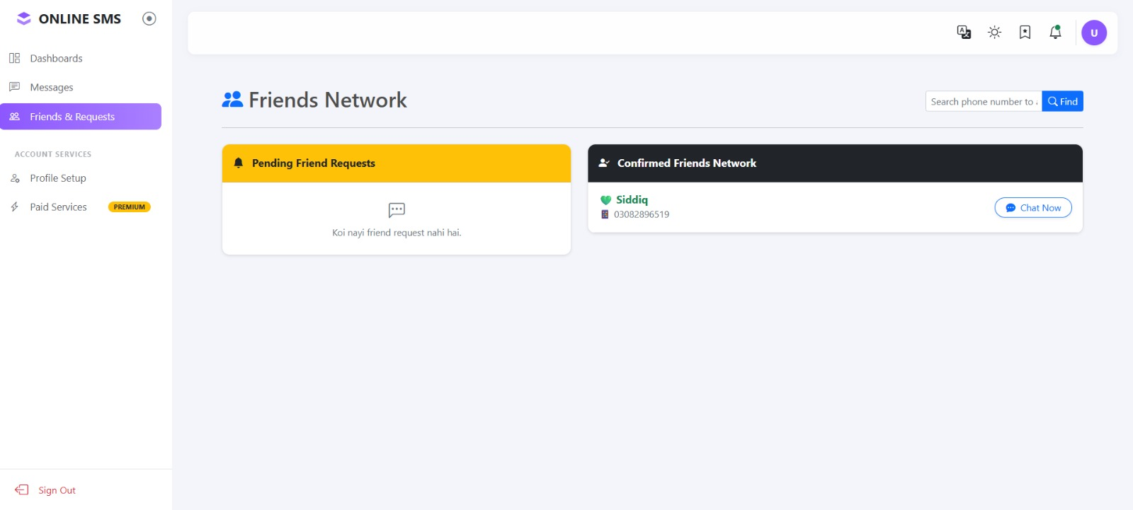

PROFILE SETTINGS:
The Profile Settings page allows users to view and update their personal information. It displays a unique user ID (which cannot be changed), along with editable fields like username, email, and phone number.
Users can easily modify their details and save changes using the “Update Profile” button. The layout is simple and clean, making it easy to manage account information.

Overall, the interface provides a straightforward way for users to keep their profile details up to date.

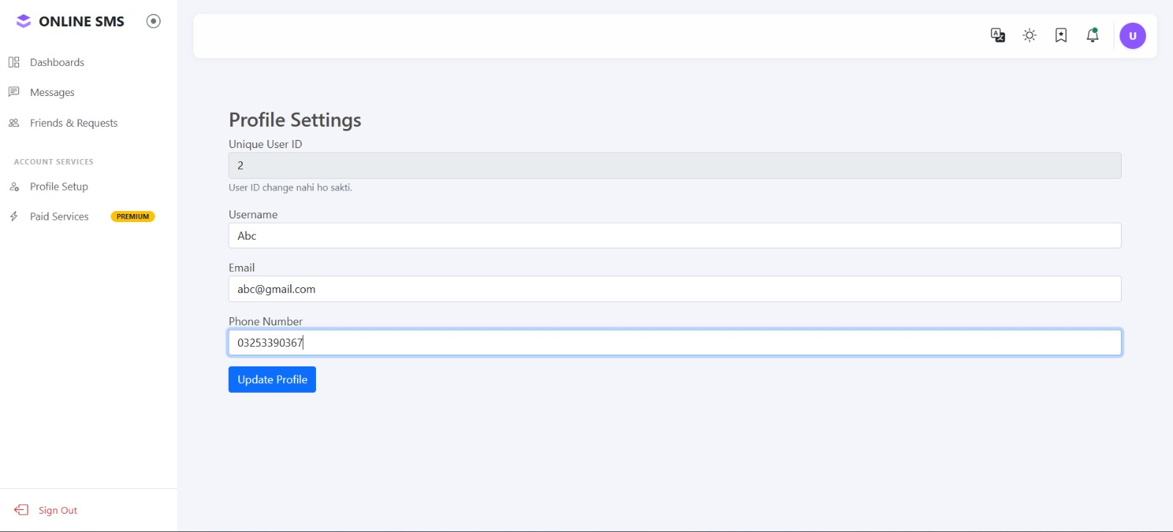

CODES SCREENSHOTS
MESSAGE CODE :

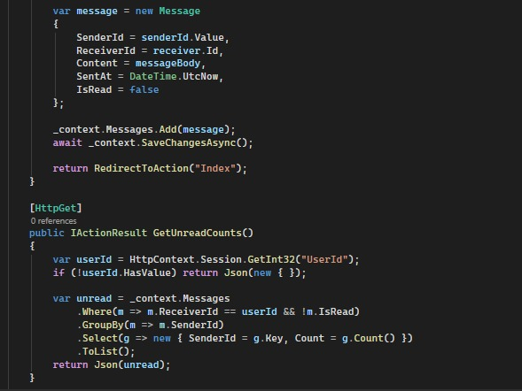

LOGIN CODE:

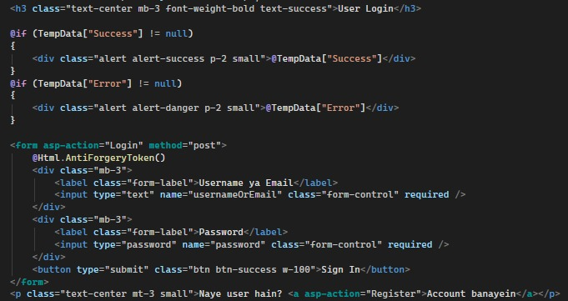

REGISTER CODE:

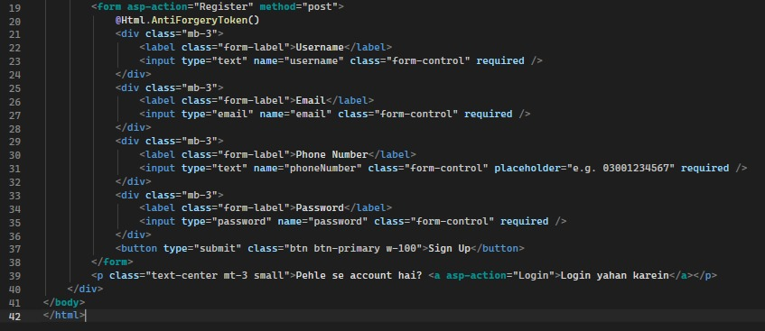

HOME CODE:

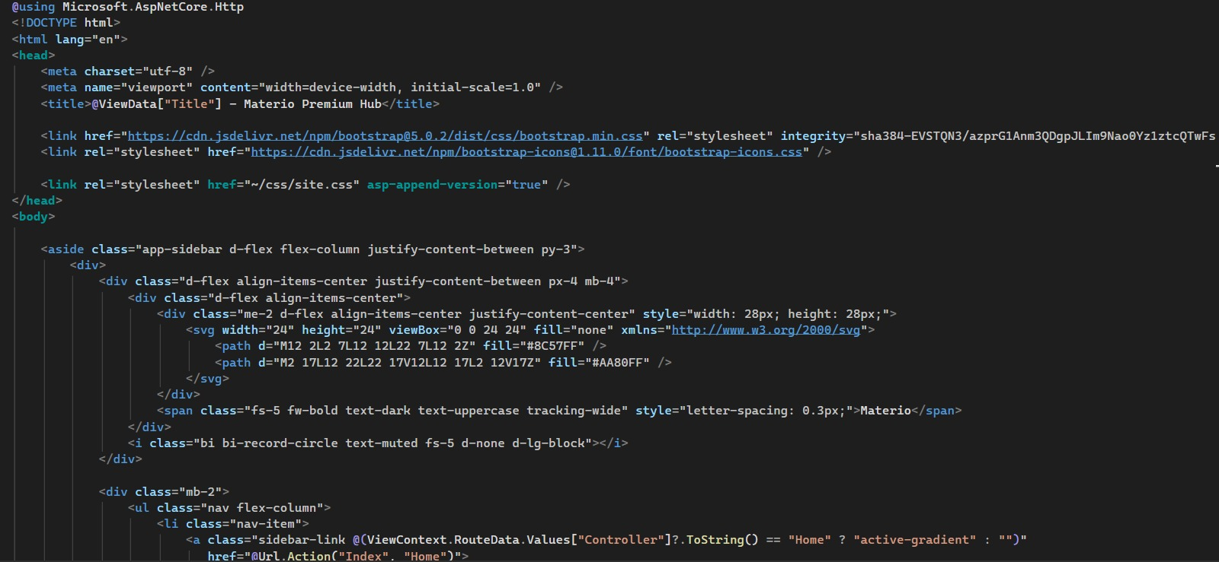

DATABASE SCREENSHOTS
DATABASE:

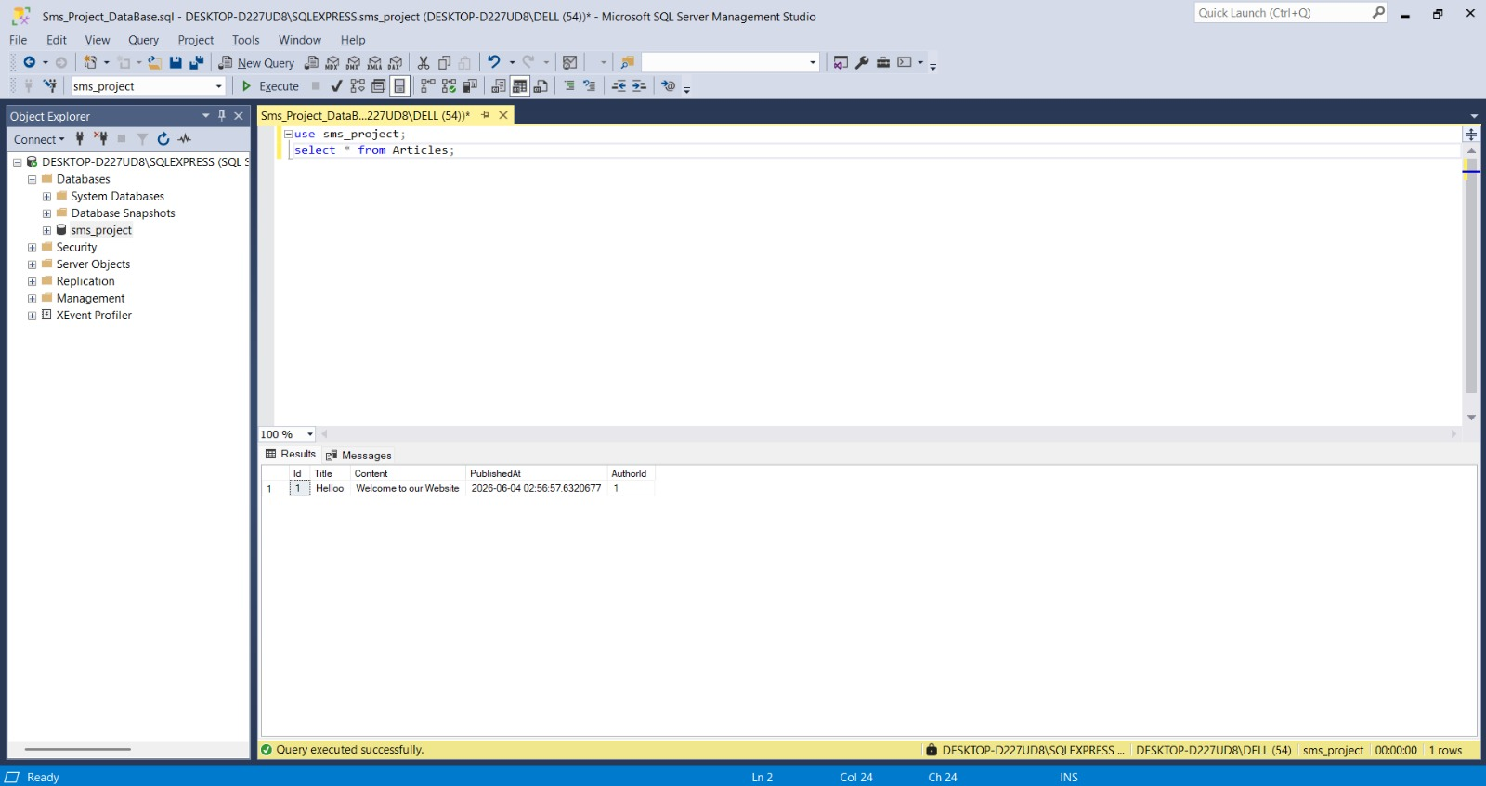

ERD DIAGRAM

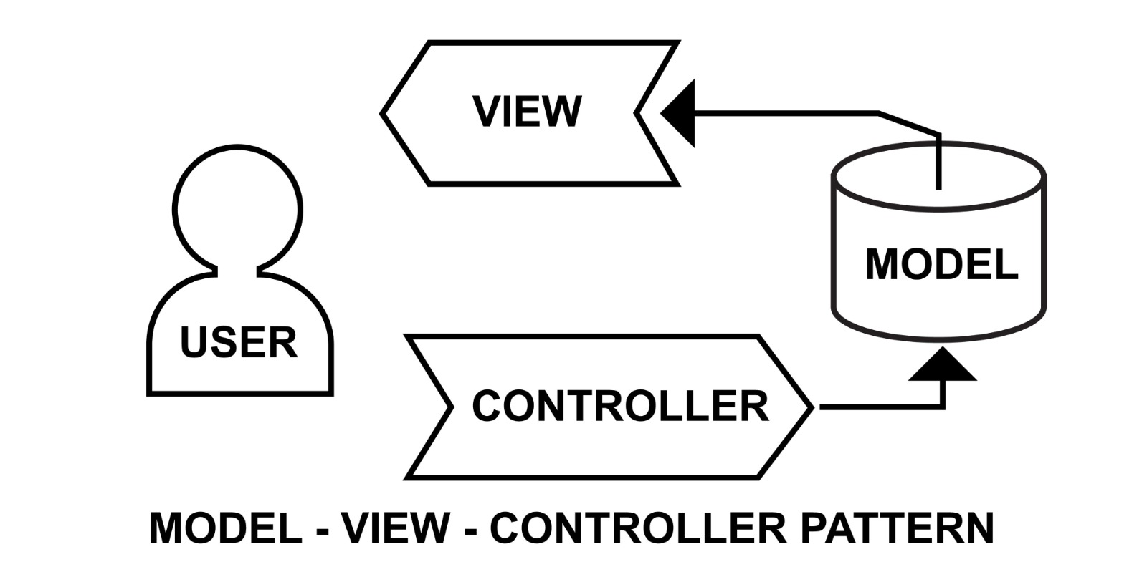

FLOWCHART DIAGRAM



